Tahmoor Public School Behaviour Code

All students have the right to be treated fairly and with dignity in an environment free from disruption, intimidation, harassment, victimization and discrimination. To achieve this, the Tahmoor Public School Behaviour Code incorporates comprehensive and inclusive strategies that create an environment with clearly defined behavioural expectations.
When parents enrol their children at Tahmoor Public School they enter into a partnership with the school. This partnership is based on a shared commitment to provide opportunities for students to take responsibility for their actions and to have a greater say in the nature and content of their learning. Collaboration between school, students and parent (s) or carer(s) is an important feature of the behaviour code.
Tahmoor Public School is committed to providing a safe, supportive and responsive learning environment for all the students we teach and model the behaviours we value in our students.
At Tahmoor Public School students are expected to:
- Respect other students, their teachers, school staff and community members.
- Follow school and class rules and follow the directions of their teachers.
- Strive for the highest standards in learning.
- Resolve conflict respectfully, calmly and fairly.
- Respect all property.
- Not bully, harass, intimidate or discriminate against anyone in our school.
- Respect all members of the school community and show courtesy to all students, teachers and community members.
- Comply with the school’s uniform policy or dress code
- Attend school every day (except when legally excused)
- Not be violent or bring weapons, illegal drugs, alcohol or tobacco into our school.

Our school will take strong action in response to behaviour that is detrimental to self or others or to the achievement of high quality teaching and learning.
The NSW Department of Education (DOE) is committed to creating quality learning opportunities for all students. This includes strengthening their cognitive, physical, social and emotional wellbeing.
Cognitive wellbeing is associated with achievement and success. Emotional wellbeing relates to self-awareness and emotional regulation. It includes how well we cope, and is often reflected by the level of a student’s resilience. Social wellbeing includes the extent to which we experience positive relationships’ and connectedness to others. Physical wellbeing is associated with the extent to which we feel physically safe and healthy.
The DOE commitment to wellbeing is for schools to support students to connect - ensuring our students are actively connected to their learning, have positive and respectful relationships and experience a sense of belonging to their school and community, succeed - ensuring students will be respected, valued, encouraged, supported and empowered to succeed and thrive - ensuring our students grow and flourish, do well and prosper.
Promoting the cognitive, emotional, and physical wellbeing of all students is of paramount importance at Tahmoor Public School. In line with our Positive Behaviour for Learning (PBL) framework we are committed to supporting students in being Safe, Respectful Learners. We implement teaching and learning approaches to support the development of skills needed by students to meet our high standards of achievement and behaviour.

SAFE
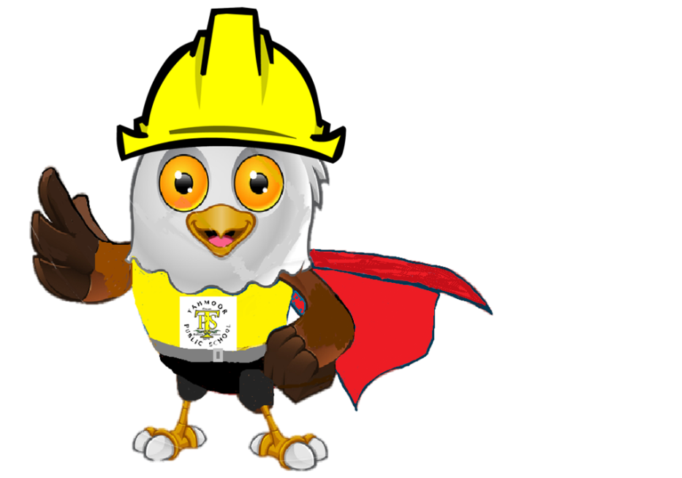

RESPECTFUL
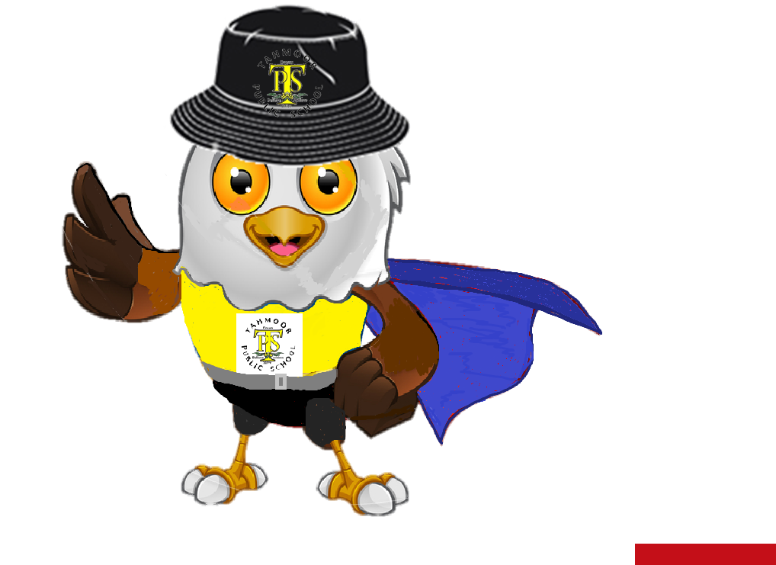

LEARNERS

Behaviour Support System
The Tahmoor Public School Behaviour Support System provides clear and explicit examples of behaviours that do not reflect the positive habits of mind that underpin our school wide Positive Behaviour System. Whilst this system acknowledges inappropriate behaviour choice and student misconduct and the consequences of those choices, it also moves to provide opportunities to support the learning and practice of expected behaviours. The system will be implemented in a consistent manner across all grades to help build a safe and supportive learning environment for all students.

The system is tiered and is implemented in the following manner:

Level 1 – Students are placed on this level by classroom teachers for exhibiting minor behaviours in class or around the school. Students will be monitored by their teacher and given opportunities to reflect upon their actions and supported in learning and demonstrating pro-social future choices.

Level 2 – Students are placed on this level by a member of the school executive for repeated minor behaviours and/or certain major behaviours. More serious consequences may be issued and parents/carers and the school will work together to support a more positive direction for the student

Level 3 – The student will be issued with a warning of suspension following repeated negative behaviours whilst on Level 2, or for exhibiting serious major behaviours. Targeted intervention from the school’s Learning Support Team may be deemed appropriate to support the student. Warnings of suspension will last for five school days.

Level 4 – Suspension from school following negative behaviours on Level 3, or for extreme major behaviours. Suspension provides an opportunity for the school, in consultation with families and all stakeholders, to plan and put into place targeted supports for the student on their return to maximise future success. On their return, students will be monitored daily by the school executive for five school days.

Level 1
Reasons For Being Placed On This Level | Consequences For Being On This Level
Incidents of minor behaviours may include:  - Inappropriate verbal language  - Inappropriate physical contact e.g. pushing, pulling, tackling, prodding.  - Littering.  - Impolite manners and not considering the rights and needs of others.  - Out of bounds.  - Office without pass.  - Late to class.  - Refusal to follow staff instructions | - Teacher will follow PBL Minor Behaviour Response process. At Step 4, student is placed on Level 1.  - Teachers will record the incident on SENTRAL.  - Note is sent home to parent / carer informing them of their child’s placement on Level One, the reasons why they have been placed on this level and how the student can work towards meeting school behaviour expectations. Teachers contact parents by phone prior to sending home a letter.  - Student remains on Level One for five (5) school days. Students are expected to demonstrate positive behaviour choices during this time reflecting expected school behaviours.  - A Return from Level note will be sent home to parent/carer.  - Lack of noticeable improvement in expected school behaviours or continued student misconduct will lead to progression to Level Two.

Level 2
Reasons For Being Placed On This Level | Consequences For Being On This Level
Major behaviour incidents may include:  - Repeated breaches of Level One behaviours  - Escalating inappropriate verbal language.  - Intentional bullying and/or taunting of others.  - Absconding from class and/or school grounds  - Destruction of school or other students’ property. | - School executive will inform student’s parents of the placement of their child on Level Two and the reasons for this placement.  - Student will be placed on three (3) days of full lunch time Yellow Room reflection. Students will catch up on any lost studies and  take part in reflective practices during these sessions designed to develop a positive behaviour plan that reflects the school behaviour expectations.  - Student may lose the opportunity to attend out of school experiences or represent the school whilst on Level Two.  - Student will remain on Level Two for five (5) school days.  - A Return from Level note will be sent home to parent/carer by a member of the school executive.  - Lack of noticeable improvement in expected school behaviours or continued student misconduct will lead to progression to Level Three.

Level 3
Reasons For Being Placed On This Level | Consequences For Being On This Level
Major behaviour incidents may include:  - Repeated breaches of Level Two behaviours  - Aggressive and dangerous behaviour towards staff, students and community members.  - Vandalism.  - Serious threatening of another student  - Directed swearing towards students.  - Smoking on school grounds.  - Refusal to attend Yellow Room.  - Using technology inappropriately at school or in ways related to school. | - Student’s parents/carers will be contacted by the Principal or school executive.  - Student will be placed on five (5) days of full lunch time Yellow Room reflection. During these reflective sessions students will be supported in the development of a positive behaviour plan that reflects the school behaviour expectations  - Student will lose the opportunity to attend out of school experiences (at principal’s discretion) or represent the school whilst on Level Three.  - Daily behaviour monitoring sheets will be completed to monitor behaviour choices whilst on Level Three. Targeted interventions may be put in place to support student.  - Student issued with a ‘Caution of Suspension’.  - Where there has been a noticeable increase in the practice of expected school behaviours students will be removed from Level 3.  - Lack of noticeable improvement in expected school behaviours or continued student misconduct can lead to progression to Suspension.

Level 4
Reasons For Being Placed On This Level | Consequences For Being On This Level
Major behavior incidents may include:  - Repeated breaches of Level Three behaviours  - Is in possession of a suspected illegal drug.  - Is in possession of a prohibited weapon  - Is violent or threatens serious physical violence.  - Engages in criminal activity related to the school.  - Extreme vandalism.  - Directed verbal assault towards staff.  - Using technology inappropriately that negatively impacts on others at school or in ways related to school. | The Principal will:  - Contact parent/carer and a meeting may be arranged.  - Parents will be initially contacted by phone, with written confirmation, detailing the reasons and duration of the suspension either accompanying the student that day or following the next.  The Principal may impose:  - Short suspensions of up to and including four school days or long suspensions of up to and including twenty school days.  Resolution  - A suspension resolution meeting will be held prior to the student being allowed to return to school. Where necessary, a risk management plan will be developed prior to the students commencing back at school.  - If no resolution is possible, a further suspension will be imposed and the matter referred to the Director Public Schools.  - In the case of issues involving violence and weapons, all issues must be satisfactorily resolved to the satisfaction of the school, prior to a student being returned to school.

PBL Minor Behaviour Response Sequence

PBL Major Behaviour Response Sequence

