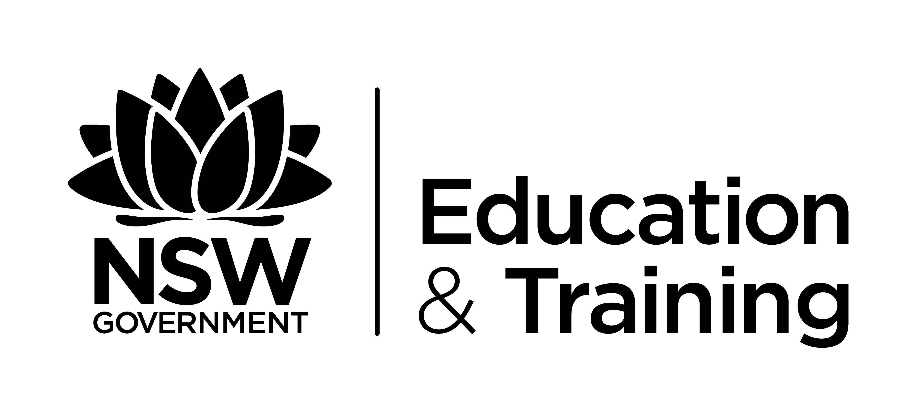
Tahmoor Public School Principal Mr David Schofield
PO Box AAA Tahmoor NSW 2573
Ph: 02 46818340 fax: 02 46831067
tahmoor-p.school@det.nsw.edu.au

BRING YOUR OWN DEVICE (BYOD) POLICY

Rationale
This strategy statement sets out requirements for student use of personal mobile electronic devices with the capability of connecting to the school’s Wi-Fi network at Tahmoor Public School. The implementation section includes purposes, principles, options and responsibilities for Tahmoor Public School teachers, students and parents/caregivers.

The purpose of this strategy is to clarify what is considered acceptable and unacceptable student use of Information and Communication Technologies (ICT), including the internet, shared network drives, laptops and mobile devices. Tahmoor Public School embraces student use of ICT in the belief that it enables students to learn in a multitude of different and powerful ways with great efficiency.

Tahmoor Public School, in consultation with its community, will allow students to bring their own personal mobile electronic devices to school for the purpose of learning. School-developed guidelines and procedures for BYOD have been communicated to staff, students, parents and caregivers.

Strategy Statement
The school network, web sites, email and electronic learning systems have been implemented with educational purpose in mind. Students will be permitted to use personal wireless devices for their own personal learning. However, all content stored on, or accessed from, the device must fit within the values of Tahmoor Public School and this policy.

The use of personal mobile devices at Tahmoor Public School will:
- deepen learning
- be personalised and student-centred; and
- meet the expectations of teachers, students, parents and caregivers within the school.

Implementation
Equity of access
If technology is considered an asset in the teaching and learning of the curriculum, then all students will need to have access to devices, as well as the opportunity to engage in educationally sound uses of the devices.

To accomplish this, the Tahmoor Public School has decided to commit to a BYOD model that involves:
- Ensuring that all students have access to a device through:
- The provision of school-owned devices to be checked out to students to be used during class whose families couldn’t afford a personally owned device.
- The ability to purchase a device from the school – on a payment plan.
2. Ensuring that teachers are ready to integrate the effective use of technology into the curriculum.

While the BYOD models could advance equity of access, they also have the potential to introduce new inequities. For example, students who have Internet access at home will benefit more from 24/7 access to devices than students who do not have Internet at home.

Network Access
If the BYOD model is to be a success, the technological infrastructure must be configured and enhanced to meet the needs of the personally owned devices on a scale probably not seen in the school in the past.

Examples of the type of policy considerations and procedures that arise related to network access for personally owned devices include:
- Security and Internet filtering that will apply to devices logged into the school network.
- A strategic technology plan that sets implementation expectations.
- Providing opportunities for student access to the network and Internet before and after school.
- Dissemination of information on programs outside the school that could support home or community access. Those programs might include information on community centres and public libraries where access is available.

An issue that is beyond the purview of the school authority, yet directly affects levels of learning, is student access to the Internet from home.

BYOD Readiness of Tahmoor Public School
The success of the BYOD implementation at Tahmoor Public School will be determined, in part, by the school's commitment to 21st century learning, the BYOD model and the preplanning and readiness of the school.

The extension, updating or applicability of these strategies on readiness in an effort to advance the effective uses of personally owned devices might include:
A Vision
Revising/updating the vision for learning in the school to include the personalisation of learning, advanced through personally owned devices for all learners.
School Improvement Processes
Using the process for school improvement to translate the vision into practice at the schools. Such work should address leadership, school learning environments, school culture, professional development, educator competencies, expectations for integration of personally owned devices into unit/lesson design, redesign of assessment to capture 21st Century skills and ICT skills.
Digital content/resources
Strategies may be required that discuss the acquisition of digital resources.
Technology readiness
Ensuring that all school infrastructure/networks are optimally configured to ensure success with personally owned devices.

Funding
Schools need to allocate funding for all aspects of BYOD implementation. Part of the process might include the repurposing of existing budget items (such as textbooks or printing) to investment in digital resources. Tahmoor P&C has been very generous in this area.

Monitoring, evaluation and review
Statement about monitoring, evaluation and review

The Role of Students
While the staff at Tahmoor Public School will make every effort, the students are responsible for preventing the loss or damage of their device.

Students are responsible for their own behaviour and actions. They are careful and respectful when using ICT facilities and devices.

Students understand and respect that there will be times when their parents/caregivers and teachers wish for them not to make use of ICT. At school, some learning will occur that does not require the use of a device. At home there will be times when parents/caregivers wish for their children to ‘disconnect’ from schoolwork or socialising with friends.

Students understand and respect the need for staff and parents/caregivers to check what they have been doing with the device. These checks will be conducted randomly throughout the whole school year.

Students are ‘cyber-smart’ and take reasonable precautions to avoid online dangers, as outlined on the Cybersmart website (www.cybersmart.gov.au). Specifically they are familiar with:
- Avoiding unwanted contact;
- Cyberbullying;
- Protecting personal information;
- Trusting online friends;
- Offensive content;
- Identity theft.

The Role of Parents / Caregivers
Parents and caregivers are ultimately responsible for setting and conveying the standards that their children should follow. Tahmoor Public School expects that those standards will be in accordance with school rules, this strategy and other school policies.

The Role of Teachers
Teachers will embrace student use of ICT in the belief that it enables students to become more powerful and efficient learners. They will provide guidance and instruction to students regarding appropriate use.

Teachers and the school will make every attempt to ensure that loss and/or damage is minimised.

Unacceptable Use
When using ICT, students should be aware of the issues relating to privacy of both themselves and others. Students should take the utmost care when using ICT equipment as it is easily damaged and expensive to replace.

Explicitly, students should not:
- Capture or distribute voice recordings, still images or video footage of any person without their permission;
- Access, create or distribute offensive material;
- Post personal details about themselves or others in electronic public spaces;
- Share their user name or password with others;
- Play games without permission;
- Delete their internet history;
- Use personal 3G internet to access web content that has been restricted by the school.

Disciplinary Actions
Generally, classroom teachers and executive will ensure that appropriate consequences are put in place for inappropriate student behaviour in relation to ICT.

